1. Create a lake formation-admin with the below set of permissions.

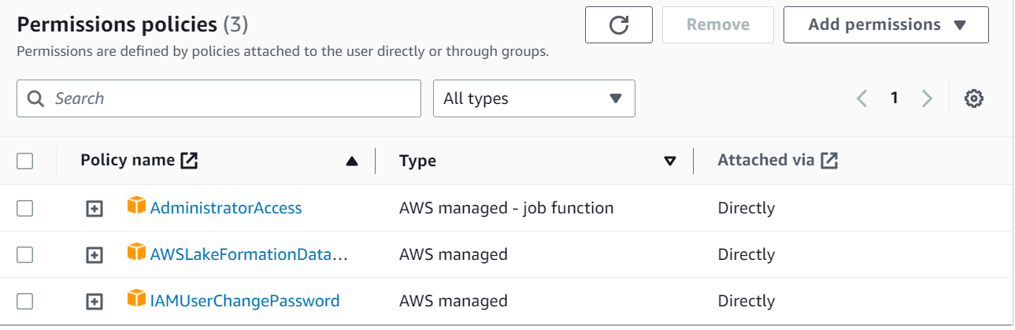

1. Add the above user as data lake admin to console

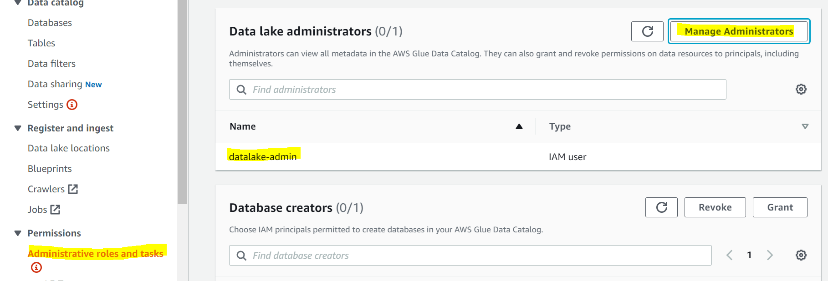

1. Log in as an IAM user & Grant DB creator access from the Lake Formation console.
2. Create s3 buckets, Enable versioning & encryption.

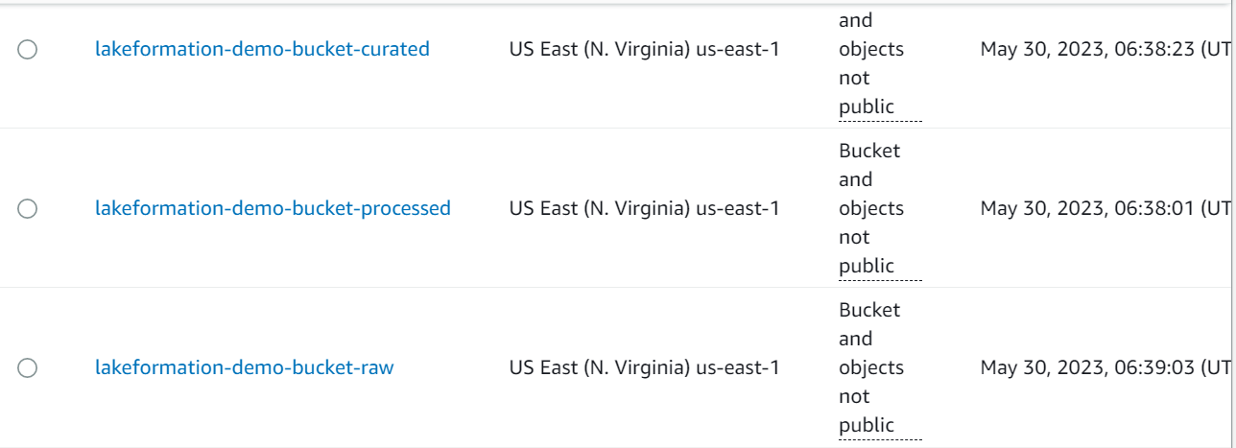

1. Create DB from the Lake formation console and link them to the respective buckets.

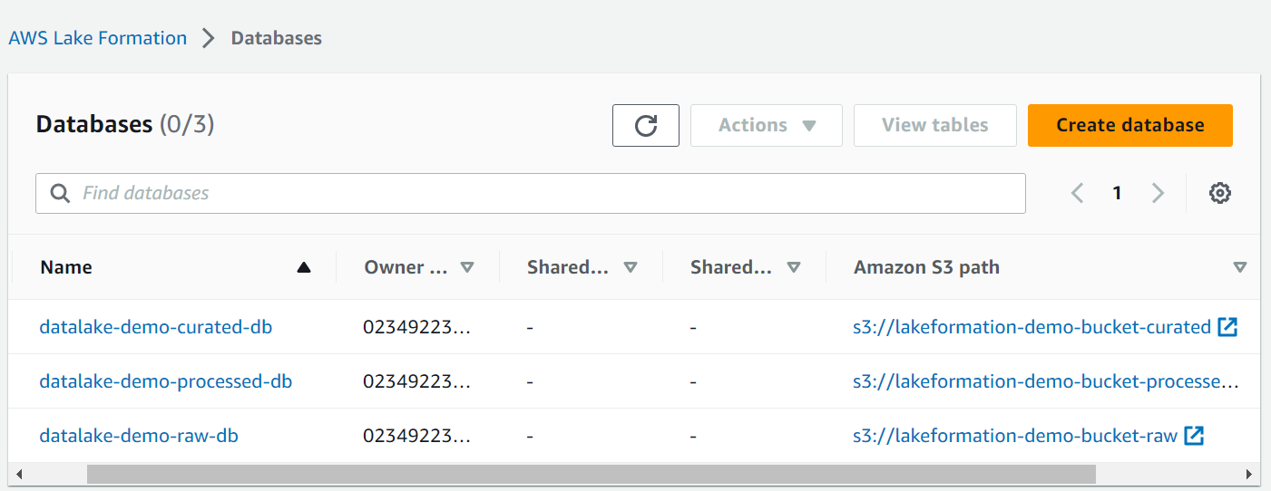

1. Add permission – add the crawler role to give DB access.

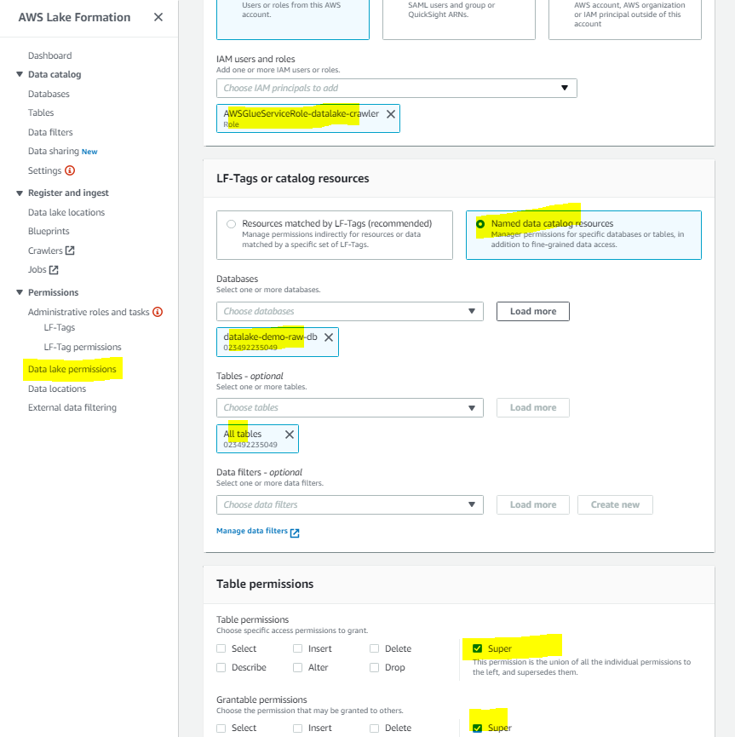

1. Create a crawler & query the data on Athena.

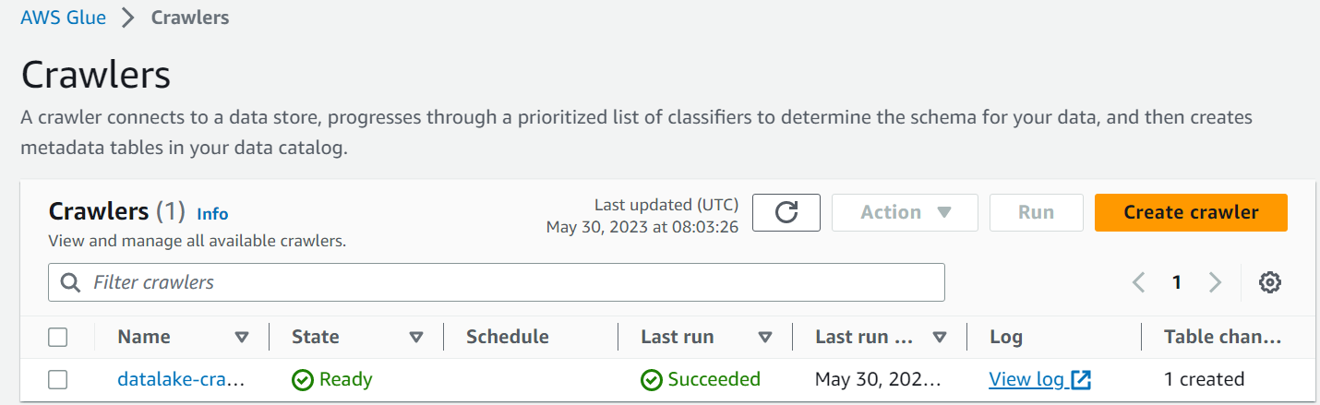

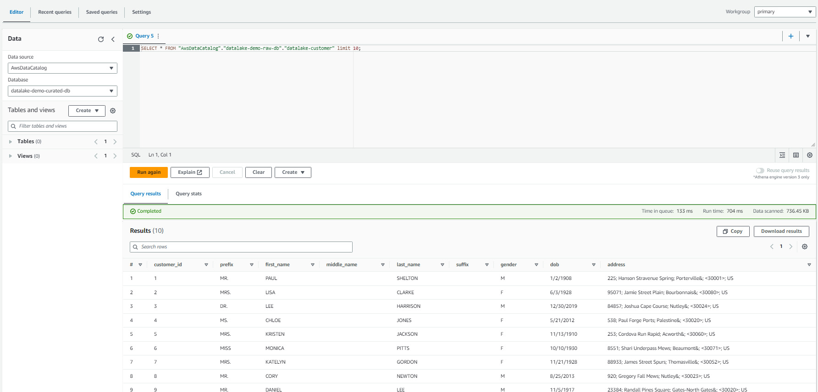

1. Create a VPC Endpoint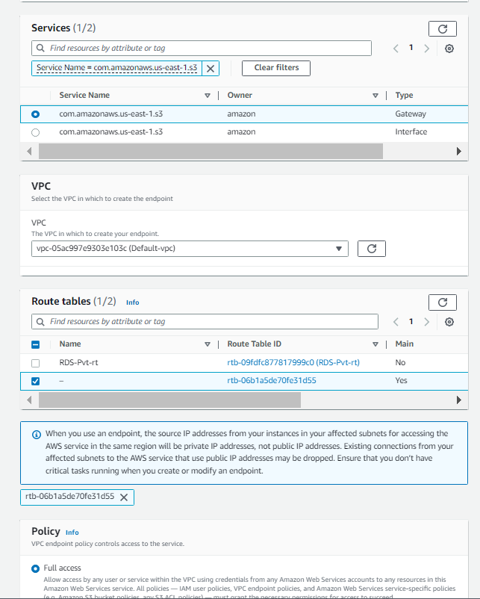

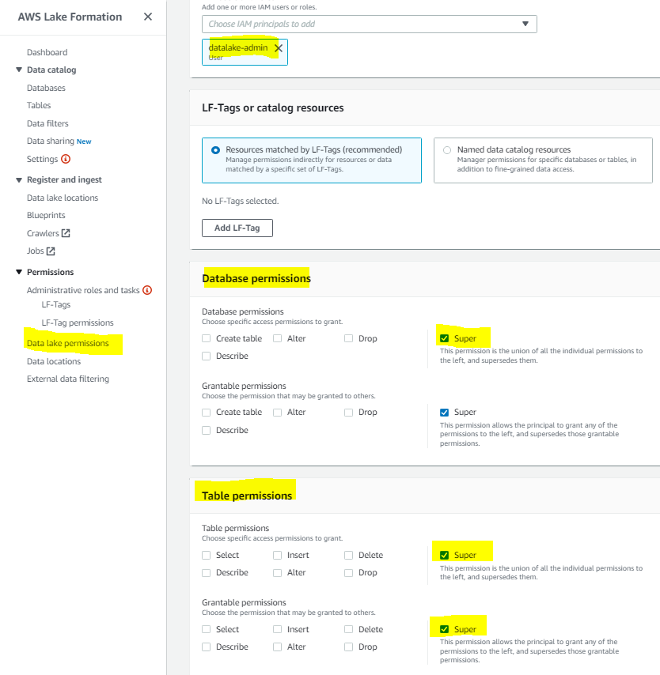

1. Connect to DB and push the data

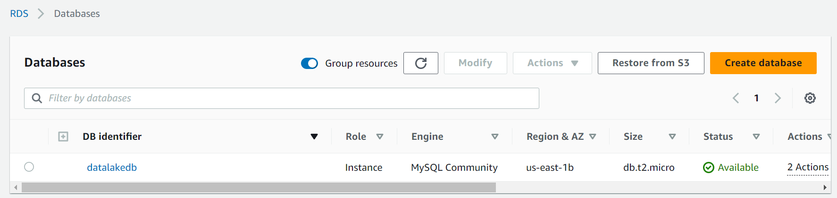

1. 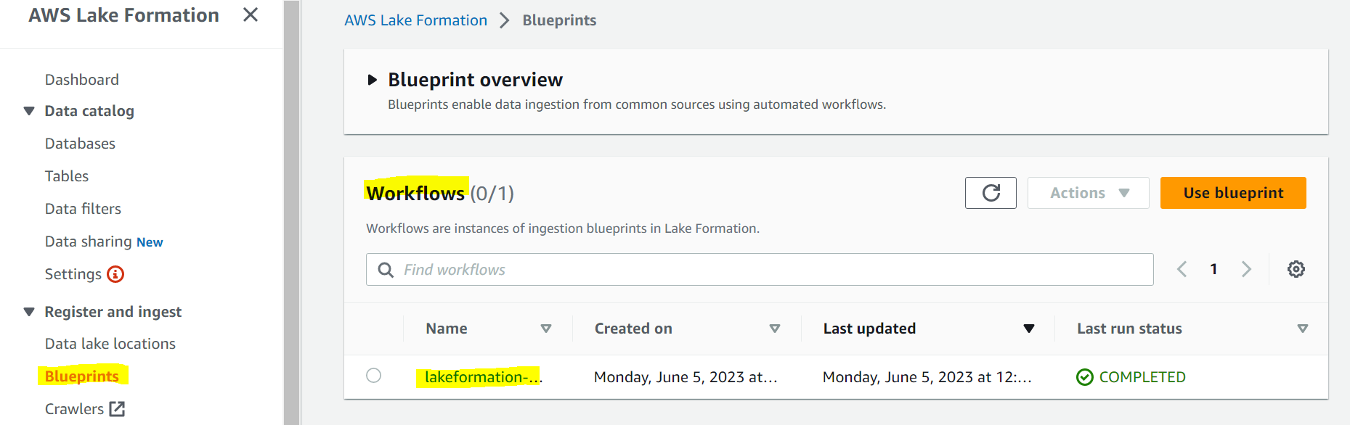
2. Create Kinesis stream

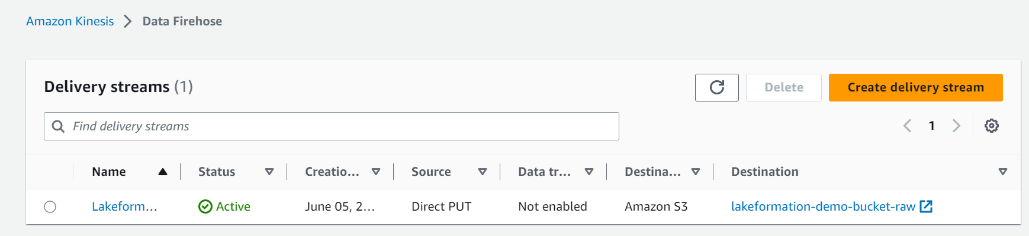

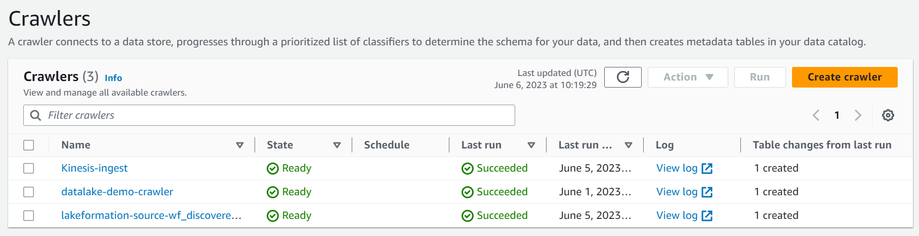

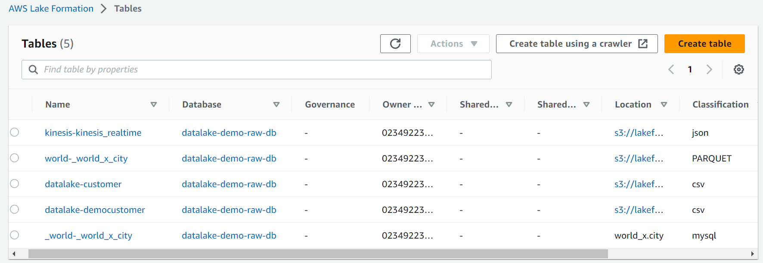

1. Create LF tags for permission.

